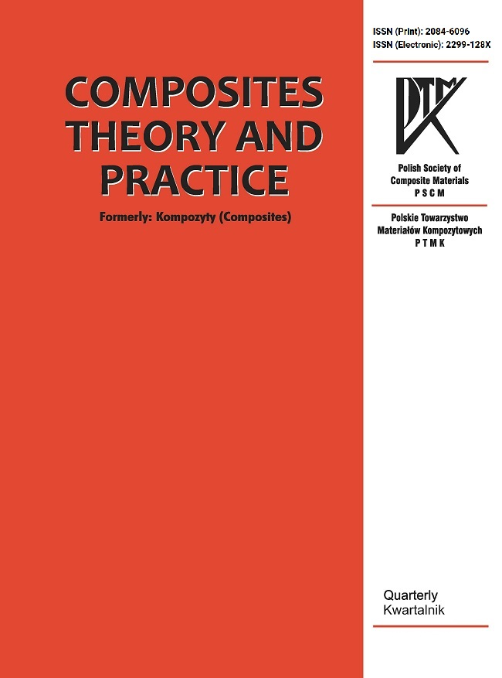
Composites Theory and Practice
https://kompozyty.ptmk.net/

Research Journal of the Polish Society Of Composite Materials
https://ptmk.net/

REVIEWER RECOMMENDATION AND COMMENTS

Name of the Reviewer (for Editors use only):

Reviewer ID:
Manuscript ID:
Manuscript title:

Authors:

Recommendation (mark X)
Acceptance as is
Acceptance with minor modifications
Acceptance with major modifications
Re-review
Rejection

Manuscript rating questions
Rating Question | Scale | Rating
The research problem addressed in the manuscript is in line with the profile of Composites Theory and Practice journal. | [1-5]
The article is at an appropriate scientific level against the background of recent publications of professional standing. | [1-5]
The research problem addressed in the manuscript is worthy of investigation. | [1-5]
The information presented in the manuscript is new and based on original research. | [1-5]
The literature review of the research problem addressed in the manuscript is sufficient. | [1-5]
The conclusions are supported by the data presented in the manuscript. | [1-5]
Does this manuscript require a linguistic revision? (1 - major, 2 - minor, 3 - no) | [1-3]

Reviewer general critical comments to Author(s) (add lines if needed)
No. | Comment
1
2
3

Reviewer specific critical comments to Author(s) (add lines if needed)
No. | Page | Line | Comment
1
2
3

